**Software Requirements**

**Specification**

**For**

**Personal Health and Fitness tracker**

**Prepared By**

Abhay Aditya N

Aneesh Adithya SR

Atyul V Bhaskar

Amogh Madhu Kashyap

Vaibhav M Chittakki

## 

## **Table of Contents**

Table of Contents...................................................................................................2  
Revision History.....................................................................................................2

1. Introduction .................................................................................................3  
   1.1 Purpose ................................................................................................3  
   1.2  Scope.........................................................................………………….3  
   1.3 Definitions, Acronyms, and Abbreviations.............................................4  
   1.4 References............................................................................................4  
   1.5 Overview...............................................................................................4
2. Overall Description.......................................................................................5  
   2.1 Product Perspective ..............................................................................5  
   2.2 Product Functions..................................................................................5  
   2.3 User Characteristics...............................................................................6  
   2.4 Constraints.............................................................................................7  
   2.5 Assumptions and Dependencies............................................................7
3. Specific Requirements.................................................................................7  
   3.1 Functional Requirements.......................................................................7   
   3.2 Non-Functional Requirements...............................................................8  
   3.3 External Interface Requirements...........................................................9

3.4 Performance Requirements………………………..………………………9

3.5 Security Requirements……………………………………………………..9

3.6 Usability Requirements…………………………………………………...10

3.7 Maintainability Requirements…………………………………………….10

1. Appendices................................................................................................11

4.1 Definitions............................................................................................11   
4.2 Acronyms.............................................................................................11   
4.3 References.................................................................…………...…….12

## 

### **Personal Health and Fitness tracker**

### **1. Introduction**

#### **1.1 Purpose**

#### The purpose of this Software Requirements Specification (SRS) record is to supply a point-by-point depiction of the Individual Wellbeing and Wellness Tracker framework. This report diagrams the utilitarian and non-functional necessities, client characteristics, imperatives, and suspicions essential for the advancement of the framework. It serves as a reference for partners, engineers, analyzers, and venture directors to guarantee a clear understanding of the system's targets and scope.

#### **1.2 Scope**

#### The Personal Health and Fitness Tracker is a software application designed to help users monitor and manage their health and physical activity. The system will follow the main measurements such as steps taken, the number of calories burned, heart rate, sleep habits and exercise routines. It will provide personalization recommendations, progressive and integrated reports with mobile devices and third health applications. The system will be available in the form of mobile applications and is a web platform, targeting individual users and medical experts.

#### **1.3 Definitions, Acronyms, and Abbreviations**

### **SRS**: Software Requirements Specification

### **API:** Application Programming Interface

### **UI:** User Interface

### **UX:** User Experience

### **GPS:** Global Positioning System

### **HRM:** Heart Rate Monitor

### **Cal:** Calories

### **BMI:** Body Mass Index

#### **1.4 References**

* IEEE 830-1998 Standard for Software Requirements Specifications
* Project Charter for Personal Health and Fitness Tracker
* Market Research Report on Health and Fitness Applications

#### **1.5 Overview**

#### This document is held in the parts that provide a full description of the health and Personal Health and Fitness Tracker system. The introduction describes the objectives, scope and structure of the document. Global description provides a high -level view of the system, including functions, user characteristics and its constraints. Specific requirements detailed functional and non -functional requirements, external interface and quality properties. Finally, the Appendices include definitions, abbreviations and references for more clearly.

### **2. Overall Description**

#### **2.1 Product Perspective**

#### The Personal Health and Fitness Tracker is an independent software system designed to integrate into mobile devices (for example, fitness bands, smart watches) and secondary health applications. (Example: Google Fit, Apple Health). It acts as a mobile application for iOS and Android platforms, with additional web dashboard for detailed analysis and reporting. The system will take advantage of cloud storage to synchronize and backup data, ensuring transparent access to some devices.

#### **2.2 Product Functions**

#### The main functions of Personal Health and Fitness Tracker include:

#### **4 monitoring operations:** Monitor steps, distance traveled, and calories burned.

#### **Health monitoring:**

#### by heart rate, sleep model and blood oxygen concentration.

#### **Exercise activity:**

#### records and types (for example, running, cycling, yoga).

#### **Objective adjustment:**

#### Allows users to identify and follow the exercise goals (for example, the number of daily steps, weight loss).

#### **Personalized Recommendations:**

#### Provides customized advice according to user data and trends.

#### **Progress report:**

#### Create a visual report and summarize the user progress.

#### **Notifications:**

#### To prompt and warn the goals, training sessions and health data.

#### **Integrated:**

#### synchronized data with mobile devices and third health applications.

#### 

#### **2.3 User Characteristics**

#### This system is designed to meet many users, including those who seek to monitor and improve their health and physical form, as well as health experts can use the system to direction. lead their customers. The end user is generally aged 18 to 65 years old and has a different level of technology flavor, from basic to intermediaries with mobile applications. These users might have specific health goals, such as weight loss, physical improvement or general health monitoring. Medical experts, such as doctors, nutrition experts and coaches, require analysis to improve reports and requiring features to monitor and effectively support their customer. In addition, IT administrators will be responsible for maintenance and system updates, ensuring operations and smooth security.

#### **2.4 Constraints**

#### The development of Personal Health and Fitness Tracker has number of constraints. The system is compatible with devices and smartphones, ensuring access to users with different devices. Adhering with health data security, such as HIPAA and GDPR,which protects user security and ensures legal members of the application. Optimization of performance is essential, because the system must operate effectively on low devices with limited treatment power. In addition, the system must support offline features, allowing users to continue monitoring activities without operating internet connection, data synchronization occurs after the connection is restored.

#### **2.5 Assumptions and Dependencies**

The successful implementation of the Personal Health and Fitness Tracker is based on several assumptions and dependencies. Assuming that users will have access to smartphones or mobile devices compatible with the system. The stability and access of the third API, like Google Fit and Apple Health, is essential for transparent data integration. Cloud storage services should be available to synchronize and backup data, ensuring the consistency of data between devices. In addition, the system assumes that users will provide an accurate and consistent data input to allow optimal functions and personalized recommendations.

### **3 Specific Requirements**

#### **3.1 Functional Requirements**

#### The system must allow users to create accounts with e-mail identification information or on social media and provide safe recovery and password recovery features. It must follow the steps, movement distance and calories burned in real time, synchronize data with mobile devices and third applications. The system must monitor the heart rate, sleep model and oxygen concentration in the blood, providing warnings for abnormal health measures such as high heart rate. Users will be able to record manual training, such as execution, bicycle or yoga, with this data classification and storage system to monitor the progress. The system allows users to set daily, weekly and monthly exercise goals, such as the number of steps or weight loss and providing visual progress indicators and reminders of the achievements of the goals. Personalized recommendations will be created on user databases, including training plans, food consultancy and sleep improvement strategy. Reports on the daily, weekly and monthly processes must be created, with intuitive graphics and graphics for easy explanation. The system must send prompts to training sessions, goals and health assessments, as well as warning abnormal or non -working health measures. The synchronization of data on some devices and platforms must occur in real time, with the management of offline data collection and automatic synchronization online. Integrated with mobile devices and third health applications, such as Google Fit and Apple Health, will be cared for to ensure sharing and transparent function. Also a Integration of a LLM at the end as a process of our further plan.

|  |  |  |  |
| --- | --- | --- | --- |
| Requirement ID | Description | Priority | Status |
| FR-01 | User registration and authentication | High | Implemented |
| FR-02 | Activity tracking | High | Planned |
| FR-03 | Health monitoring | High | Implemented |
| FR-04 | LLM Model | High | Implemented |

#### **3.2 Non-Functional Requirements**

#### The system must be very reliable, with the use of 99.9%, ensuring minimum interruptions for users. It supports at least 10,000 users simultaneously without impaired performance. The user interface must be intuitive and react, with the maximum loading time of 2 seconds for all screens. The system must adhere with data security regulations such as HIPAA and GPDR, ensuring that all user data is encrypted and stored completely safely. It should be compatible with iOS and Android operating systems, as well as the main mobile devices. The system is developed to adapt to the future growth of the user facility and supplement the functions. The person must provide complete documents and support developers and administrators.

|  |  |  |
| --- | --- | --- |
| Category | Requirement | Metrics |
| Performance | System must handle 10,000 users | Concurrent users supported |
| Security | Data encryption using AES-256 | Encryption standard |
| Usability | Maximum load time of 2 seconds | UI responsiveness |

#### **3.3 External Interface Requirements**

The system should provide user-friendly mobile interface for iOS and Android devices, with clean and eye-catching designs. It must include online dashboard for detailed analysis of data and data reporting, accessible through browsers such as Chrome, Firefox and Safari. The system must be integrated into mobile devices via Bluetooth and Wi-Fi, ensuring transparent data transmission. APIs must be provided to integrate with third health applications, such as Google Fit and Apple Health, using Restful protocols. The system must support the notification of pushing and warnings, sent via the Firebase (FCM) cloud message and the Apple (APN) push notice.

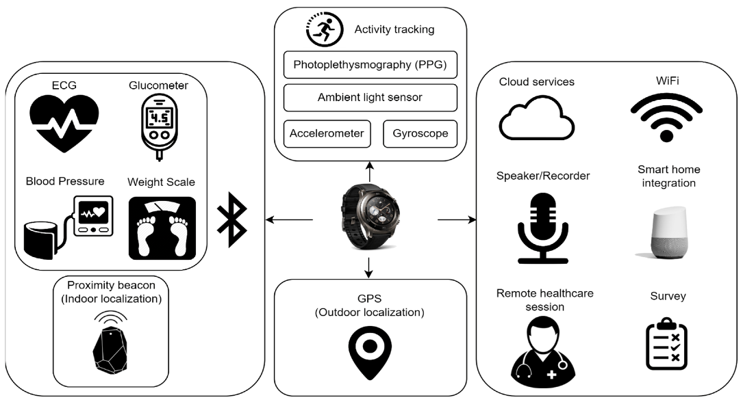

#### **3.4 Performance Requirements**

The system must process and display user data in real time, with a maximum delay of 1 second to update the data. It must manage up to 10,000 users simultaneously without reducing performance.

The synchronization of data between devices and clouds must occur within 5 seconds depending on the recovery of the connection. The system must support offline features, allowing users to monitor data activities and data diaries without operating internet connection, with automatic synchronization after being restored.

#### **3.5 Security Requirements**

The system must encrypt all user data both during transportation and when resting using AES-256 encryption. It must perform multi -factors authentication (MFA) for user accounts to improve safety. Access to sensitive health data must only be limited to authorized users, with access control based on the role (RBAC). The system must undergo regular safety audit and evaluate gaps to ensure compliance with the industry standards. All the third integration must be confirmed to follow safety before implementation.

**3.6 Usability Requirements**

The system must include user -friendly interface with clear navigation and minimum learning curves. It must provide integrated information, instructions and instructions for new users. The interface must be accessible to users to be disabled, according to WCAG 2.1. The system must support some languages ​​to meet the global user basis. User feedback mechanisms, such **as surveys and notes, must be done to continuously improve persuasion.**

**3.7 Maintainability Requirements**

The system must be designed with modular architecture to facilitate updating and easy maintenance. It shall include complete monitoring and monitoring tools to diagnose and solve problems quickly. The code facility must follow the best practices in the industry, including the appropriate document control and version. Regular updates must be published to discuss errors, add new features and improve performance. The system must support the rear compatibility to ensure smooth transformation for users in the update process.

### **4. Appendices**

#### **4.1 Definitions**

#### Activity Tracking: The process of monitoring physical activities such as steps, distance, and calories burned.

#### Health Monitoring: The process of tracking physiological metrics such as heart rate, sleep patterns, and blood oxygen levels.

#### Goal Setting: The feature that allows users to define and track fitness objectives, such as daily step counts or weight loss targets.

#### Data Synchronization: The process of ensuring that user data is consistent across multiple devices and platforms.

#### Wearable Devices: Electronic devices worn on the body, such as fitness bands and smartwatches, that collect health and fitness data.

#### 

#### **4.2 Acronyms**

SRS: Software Requirements Specification

API: Application Programming Interface

UI: User Interface

UX: User Experience

GPS: Global Positioning System

HRM: Heart Rate Monitor

Cal: Calories

BMI: Body Mass Index

HIPAA: Health Insurance Portability and Accountability Act

GDPR: General Data Protection Regulation

FCM: Firebase Cloud Messaging

APNs: Apple Push Notification Service

AES-256: Advanced Encryption Standard with a 256-bit key

MFA: Multi-Factor Authentication

RBAC: Role-Based Access Control

WCAG: Web Content Accessibility Guidelines

#### **4.3 References**

IEEE 830-1998 Standard for Software Requirements Specifications.

Project Charter for the Personal Health and Fitness Tracker.

Market Research Report on Health and Fitness Applications.

HIPAA Compliance Guidelines for Health Data Security.

GDPR Compliance Requirements for Data Privacy.

WCAG 2.1 Accessibility Standards.

Documentation for Firebase Cloud Messaging (FCM) and Apple Push Notification Service (APNs).

**Screenshots of the project:**

